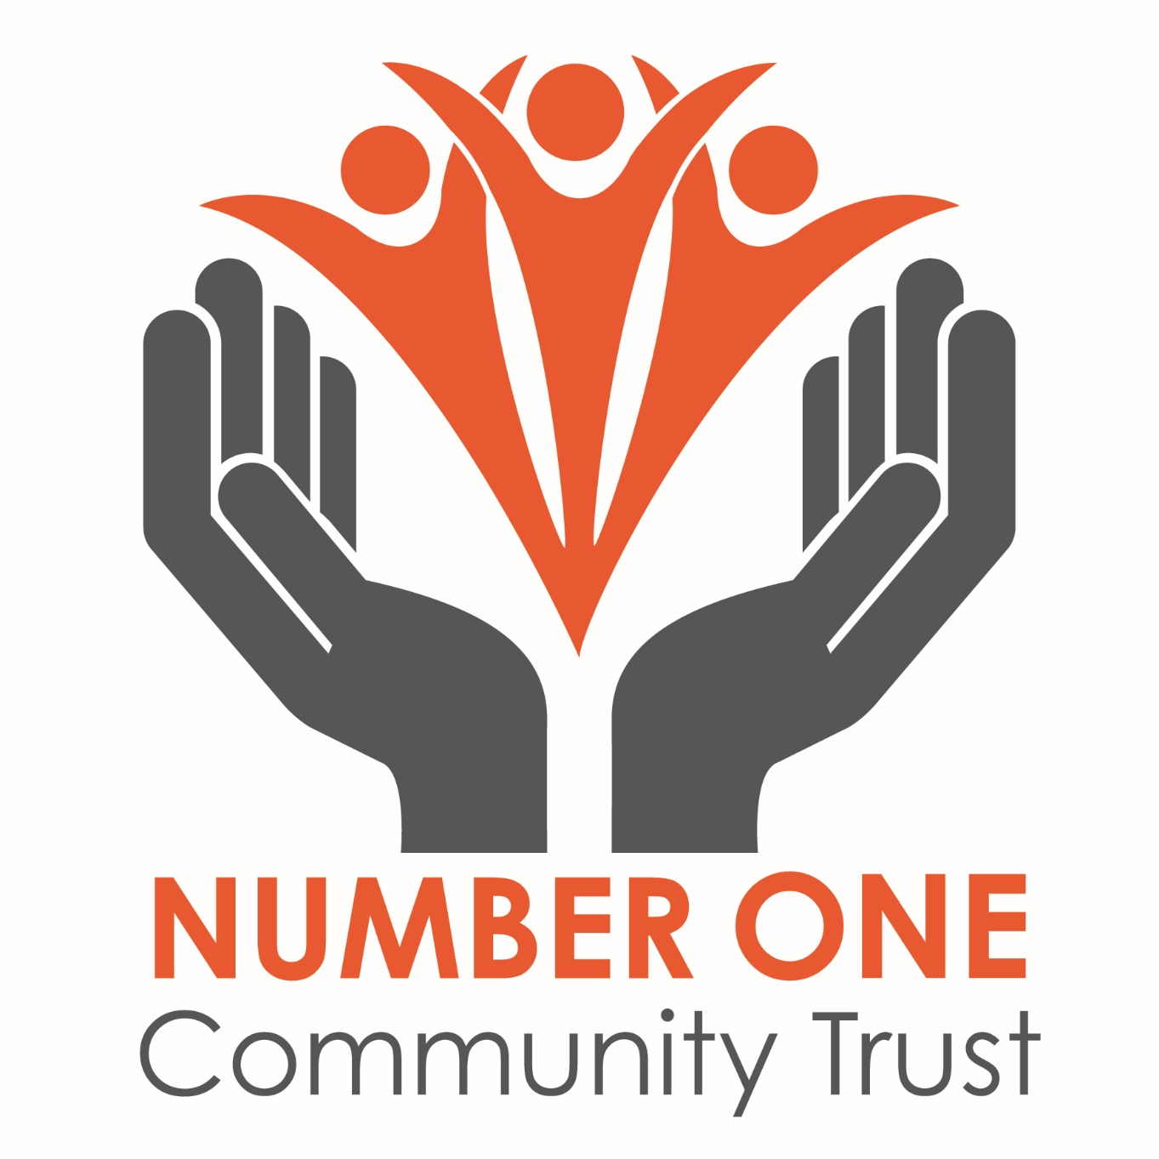

Allergen information record
October 2018

** indicates what allergens are in each dish
Breakfast Menu
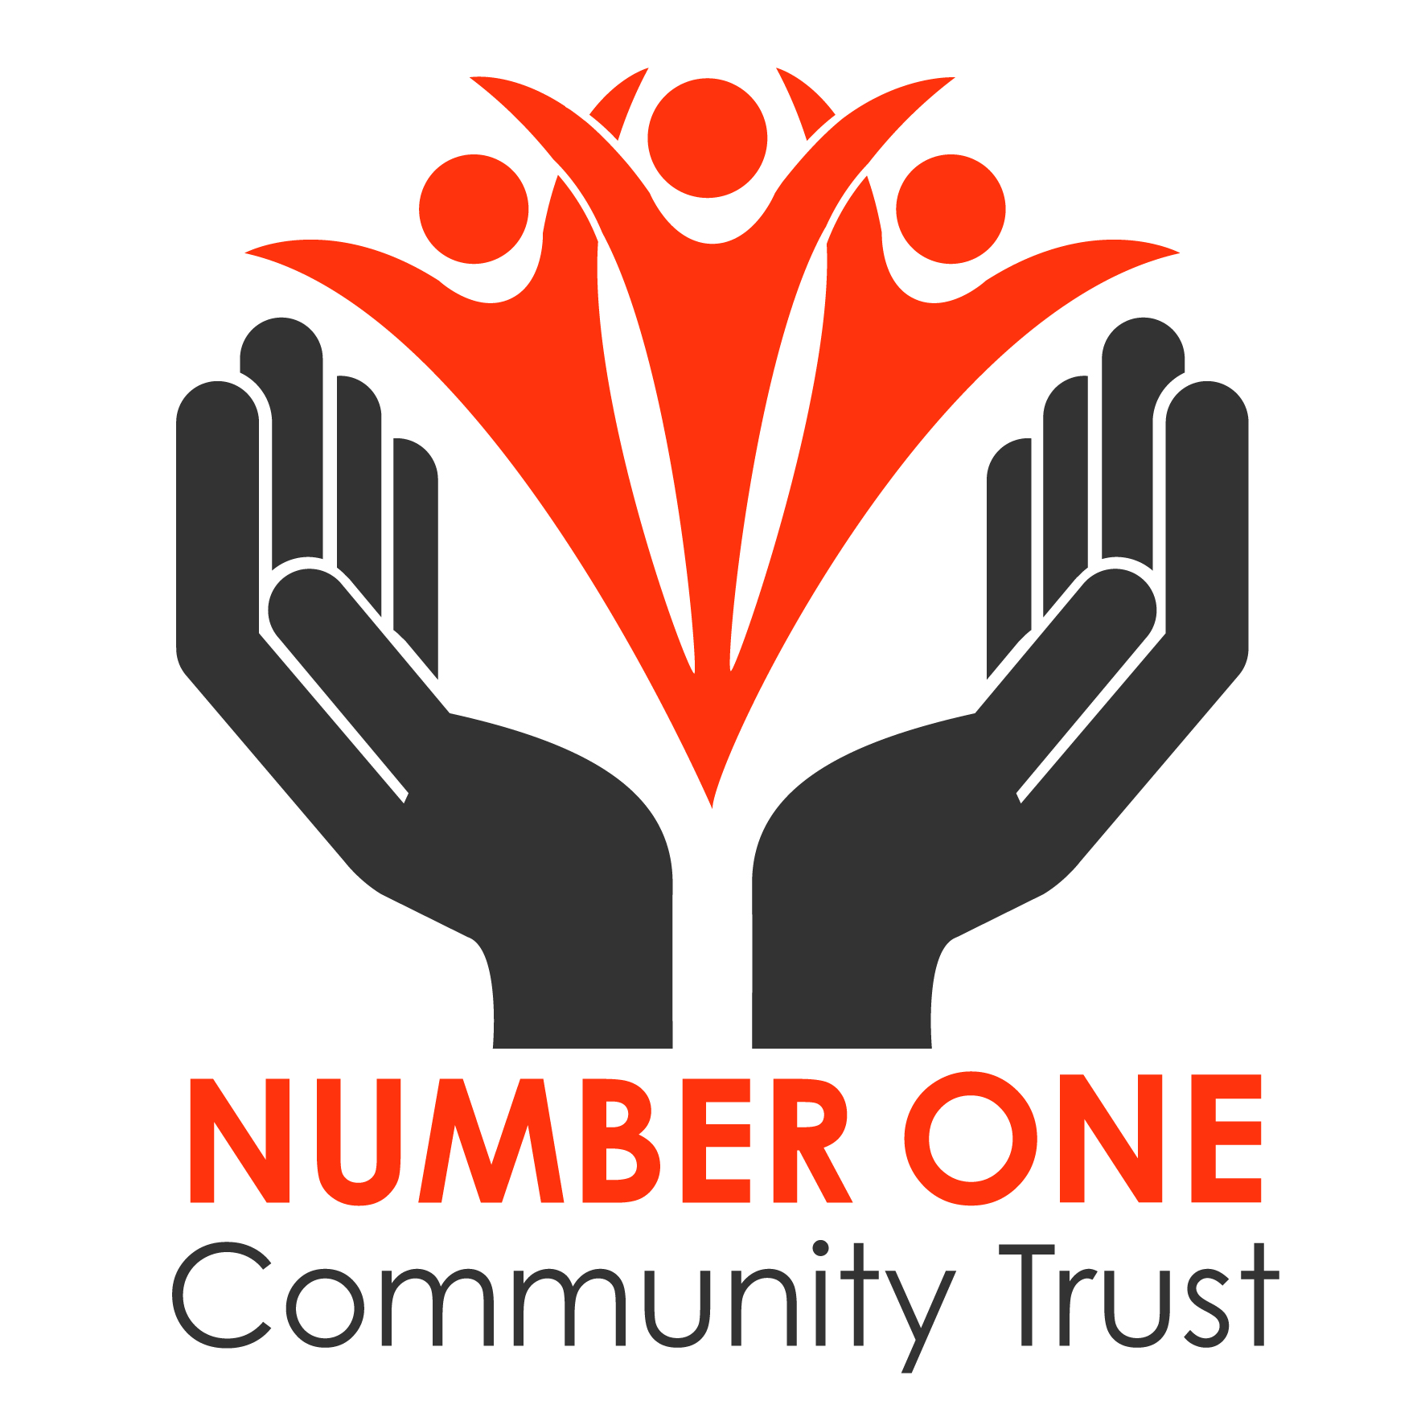
- The Number 1
Bacon, egg, fresh tomato, mushrooms, baked beans, toast with butter, tea & coffee
** egg, wheat, milk, soya, barley
- The Full Hog
Bacon, egg, sausage, hash brown, fresh tomato, mushrooms, baked beans, toast with butter, tea & coffee ** egg, wheat, sulphites, milk, barley, soya
- The Ranch
Bacon, egg, fresh tomato, sausage, mushrooms, beef burger, fried onions, baked beans, chips, tea & coffee
** egg, sulphites, wheat, soya, milk, barley
- Slimming world
Bacon, fresh tomato, mushrooms, egg, baked beans, toast with butter, tea & coffee
** egg, milk, wheat, barley, soya
- Veggie Breakfast
Vegetarian sausage, fresh tomato, mushrooms, egg, baked beans, toast with butter, tea & coffee
** egg, milk, barley, wheat
- Breakfast Muffin
Bacon or sausage, egg, cheese, bread muffin, hash brown
** egg, sulphites, wheat, milk
Black pudding ** barley, oats, wheat
Snack Menu
- Beans on toast
Baked beans, bread (white or brown) butter
** soya, wheat, barley, milk
- Eggs on toast
Egg, bread (white or brown) butter
** egg, milk, soya, wheat, barley
- Bacon/Sausage & egg sandwich
Bacon, sausage, bread (white or brown) egg, butter
** sulphites, wheat, egg, soya, barley, milk
- Bacon sandwich
Bacon, bread (brown or white) butter
** soya, wheat, barley, milk
- Cheese on toast
Cheese, bread (brown or white)
** milk, soya, wheat, barley
- Toast x2 with condiments
Bread (brown or white) butter, jam, marmite, peanut butter
** soya, wheat, barley, nuts, celery, rye, oats
- Chips
- Cheesy chips
** milk
- Sweet potato fries
Lunch Menu
- 3 egg Omelette
Egg, ham, onion, mushroom, tomato, cheese, bacon, sausage
** egg, milk, sulphites, wheat
- Jacket potato
Potato, butter, beans, cheese, ham, tuna
** milk, fish
- Beef burger, chips & beans
Beef burger, chips, cheese, onions, bacon, bread roll, chips, baked beans
** soya, sulphites, wheat, milk,
- Sandwiches
Bread (white & brown), ham, cheese, tuna mayonnaise, salad
** eggs, soya, wheat, barley, milk, fish
- Ham, eggs & chips
** egg
- Chicken nuggets, chips & beans/peas
Chicken nuggets, chips, baked beans, peas
** wheat, barley, celery, milk, oats, sulphites, milk

- Hotdog, chips & beans/peas
Sausage, bread roll, chips, beans, peas
** sulphites, wheat, soya, barley
- Macaroni cheese
Pasta, cheese, flour, milk, mustard
** wheat, milk, mustard

Children’s Menu
- Chicken nuggets, chips & beans/peas
Chicken nuggets, chips, beans, peas
** wheat, barley, celery, milk, oats, sulphites
- Sausage, egg, chips & beans
Sausage, egg, chips, beans
** sulphites, wheat, egg
- Beans on toast
Beans, bread (brown or white) butter
** soya, wheat, barley, milk
- Sausage & chips
Sausage, chips
** sulphites, wheat
- Fish fingers & chips
Fish fingers, chips
** fish, wheat
- Fish finger sandwich
Fish fingers, bread (brown & white), butter
** fish, wheat, soya, barley
- Macaroni cheese
Pasta, cheese, flour, milk, mustard
** wheat, milk, mustard

- Ham & chips
Ham, chips
- Cheese on toast
Cheese, bread (brown or white)
** milk, soya, wheat, barley
- Scrambled egg on toast
Egg, bread (white or brown), butter, milk
** egg, soya, wheat, barley, milk
- Kids lunch boxes
Bread, butter, jam, peanut butter, marmite, chocolate spread, ham, cheese, jelly, kinder bar, raisins, fruit, pom-bears, mini baby bell
** soya, wheat, barley, nuts, celery, oats, rye, milk,

Specials
- Chilli con carne
Beef mince, chopped tomatoes, kidney beans, rice, onions, peppers, spices, stock cube, tomato puree
** celery, cereals containing gluten, crustaceans, egg, fish, milk, soya
- Hummus & pitta
Chick peas, garlic, tahini, pitta bread
** sesame, gluten, wheat
- Curried sweet potato & butternut squash soup
Sweet potato, butternut squash, onion, garlic, butter, cream, vegetable stock cube, curry powder
** celery, gluten, crustaceans, egg, fish, milk, soya
- Cottage pie
Beef mince, celery, onion, beef stock cube, carrots, peas, missed herbs, chopped tomatoes, tomato puree, sweet potato, butter
** celery, gluten, crustaceans, egg, fish, milk, soya,
- Tomato soup
Fresh tomatoes, vegetable stock, carrots, onions, celery, garlic, mixed herbs
** celery, gluten, crustaceans, egg, fish, milk, soya,

- Bacon & cheese Quiche
Milk, cheese, eggs, bacon, pastry
** eggs, milk, wheat
- Cheese & onion Quiche
Milk, cheese, eggs, onion, pastry
** eggs, milk, wheat
- Cauliflower & broccoli cheese bake
Cauliflower, broccoli, milk, plain flour, butter, mustard, leeks, garlic
** wheat, milk, mustard
- Spaghetti Bolognese
Beef mince, chopped tomatoes, onion, garlic, pasta, peppers, herbs, tomato puree, stock cube
**celery, gluten, crustaceans, egg, fish, milk, soya
- Ratatouille with a choice of pasta or rice
Courgette, Fresh tomatoes, roasted peppers, onion, leek, vegetable stock cube, garlic
** celery
- Mediterranean Chicken thighs in tomato sauce
Chicken Thighs, fresh tomatoes, peppers, onions, garlic, herbs, sugar, Chicken stock
**Wheat, Soya, MSG

Sweet treats
- Coffee & walnut cake
Eggs, self-raising flour, sugar, butter, coffee, walnuts, icing sugar
** eggs, wheat, nuts, milk
- Victoria sponge
Eggs, self-raising flour, sugar, butter, jam, icing sugar, vanilla extract
** eggs, wheat, milk
- Chocolate cake
Eggs, self-raising flour, sugar, butter, icing sugar, Nutella spread, coco powder
** eggs, wheat, milk, nuts, soya

