Children’s menu

Chicken nuggets (6) & chips: £2.50
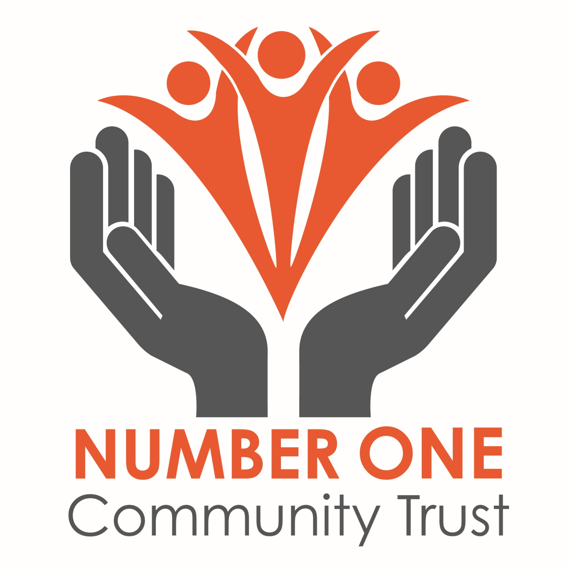
Sausage, egg (1) chips & beans: £3.00
Beans on toast: £1.50
Sausage & chips: £2.50
Fish fingers (4) & chips: £2.50
Fish finger sandwich: £2.00
Mac ‘n’ Cheese: £2.50
Ham & chips: £2.50
Cheese on toast: (1 slice) £1.50
Scrambled egg on toast: (1 slice) £1.50

*Additional items are charged at 60p extra
e.g beans, peas, egg, cucumber sticks & side salad

